E-Learning Module
Training Manual

Step One – Get up this link: https://hope.learnupon.com/users/sign_in
This page will appear:
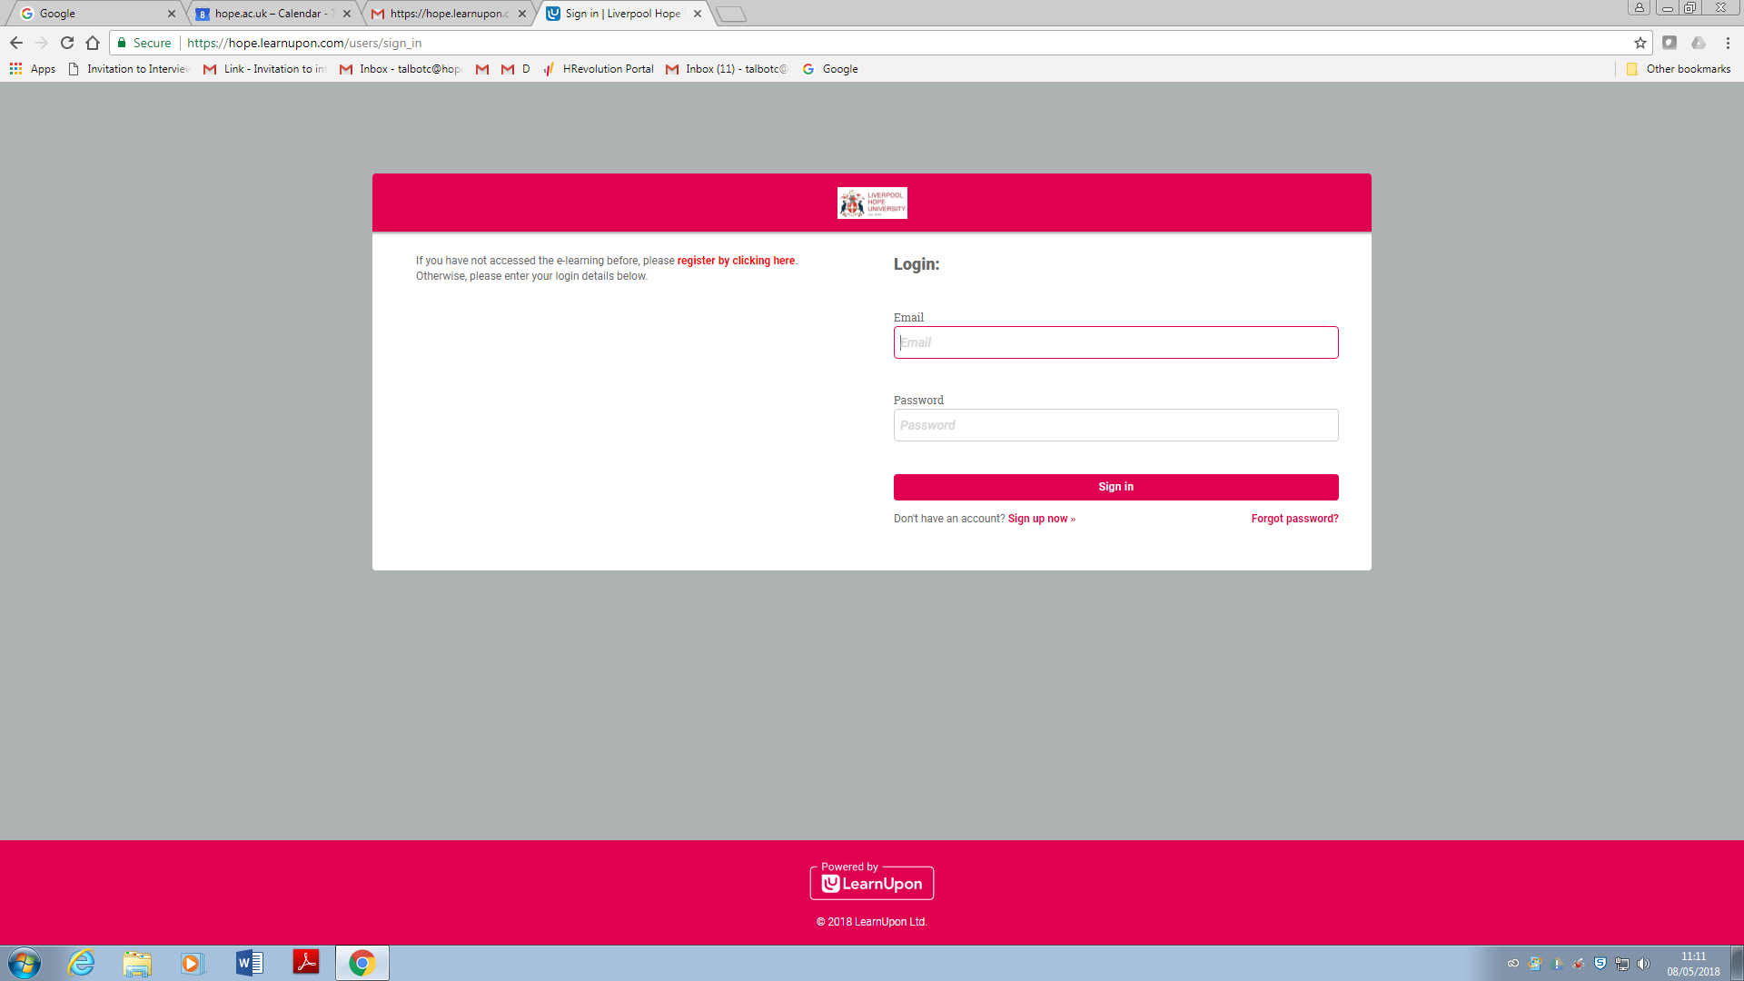

If you have already completed the Equality and Diversity Training module, you will already have a log in. If you cannot remember the password, please click on ‘forget password’ and follow the instructions.
Step Two – Either login or Click ‘Sign up now’
If you get a black screen whilst trying to log into the training package, please go to page 7 of this manual for further instruction.

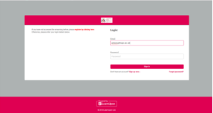

Step Three – If it is your first time logging in, enter your Hope email address and create a password.
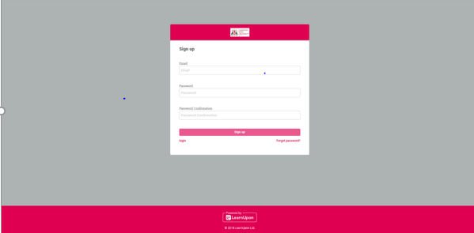

Step Four – On your screen, click ‘browse the catalogue’

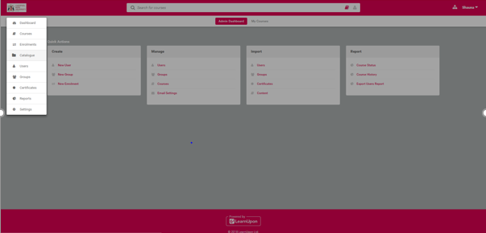

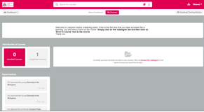

Step Five – There will be various different modules as options, please click on the module you would like to complete, Click ‘Enrol in Course’ and then ‘yes’ when the prompt comes up

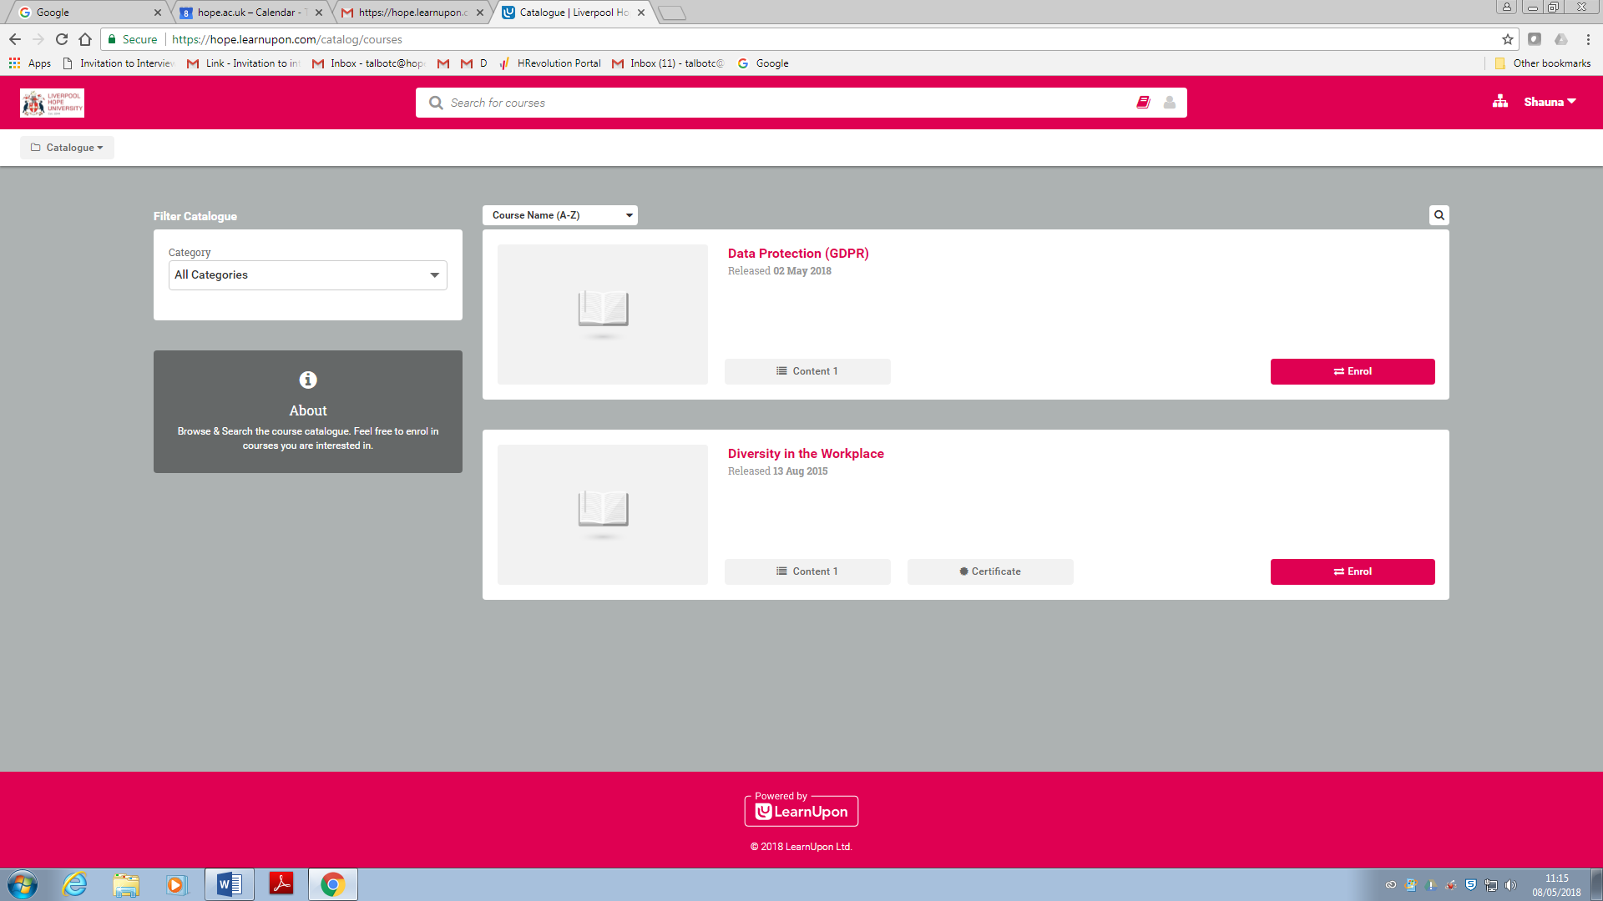

Step Six – In order to commence the session, click ‘launch’ and follow the session through. There should be an option at the end to print a certificate upon successful completion.
PLEASE NOTE:
If you are using Google Chrome, the screen may appear black, this may be because of the google chrome settings. Please open a new webpage and copy the following link into your Chrome search bar: chrome://flags/#autoplay-policy
Scroll down to the highlighted area (should be in yellow)
Then change the policy to No user gesture is required, you should be able to continue with the course.

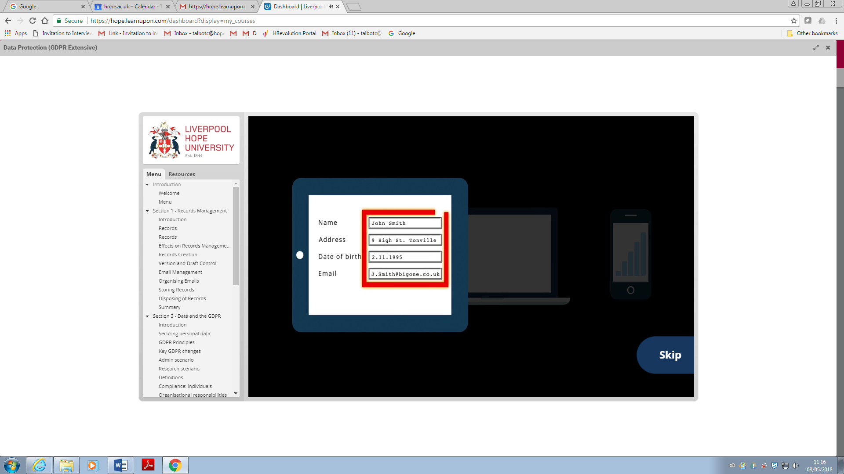
If you need to leave the session at any time:
